ultramirinc.champs_mood

Class LoginActivity

java.lang.Object

android.content.Context

android.content.ContextWrapper

android.view.ContextThemeWrapper

android.app.Activity

android.support.v4.app.SupportActivity

android.support.v4.app.FragmentActivity

android.support.v7.app.AppCompatActivity ultramirinc.champs_mood.LoginActivity

All Implemented Interfaces:

android.app.LoaderManager.LoaderCallbacks<android.database.Cursor>, android.content.ComponentCallbacks, android.content.ComponentCallbacks2, android.support.v4.app.ActivityCompat.OnRequestPermissionsResultCallback, android.support.v4.app.ActivityCompatApi23.RequestPermissionsRequestCodeValidator, android.support.v4.app.TaskStackBuilder.SupportParentable, android.support.v7.app.ActionBarDrawerToggle.DelegateProvider, android.support.v7.app.AppCompatCallback, android.view.KeyEvent.Callback, android.view.LayoutInflater.Factory, android.view.LayoutInflater.Factory2, android.view.View.OnCreateContextMenuListener, android.view.Window.Callback



public class LoginActivity

extends android.support.v7.app.AppCompatActivity

implements android.app.LoaderManager.LoaderCallbacks<android.database.Cursor>

Created by Etienne Berube on 2017­03­23. A login screen that offers login via email/password.

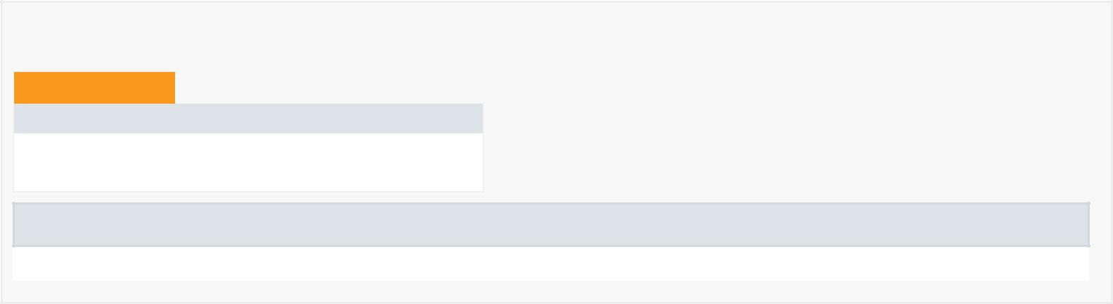

*Nested Class Summary*

Nested Classes

Modifier and Type Class and Description

private static interface LoginActivity.ProfileQuery

Interface for the profile query.

Nested classes/interfaces inherited from class android.support.v4.app.SupportActivity

android.support.v4.app.SupportActivity.ExtraData



*Field Summary*

Fields

|  |  |
| --- | --- |
| Modifier and Type | Field and Description |
| private boolean | cancel |
|  | Contains a boolean |
|  | value of cancellation for |
|  | the account that is |
|  | logging in |
|  |  |
| private com.google.firebase.auth.FirebaseAuth | firebaseAuth |
|  | Defining Firebase auth |
|  | object |
| private android.view.View | focusView |
|  | Contains a View of the |
|  | focus of the account that |
|  | is logging in |
|  |  |
| private android.widget.AutoCompleteTextView | mEmailView |
|  | Contains a |
|  | AutoCompleteTextView |
|  | of the email of the |
|  | account that is logging in |
| private android.view.View | mLoginFormView |
|  | Contains a View of the |
|  | login form of the |
|  | account that is logging in |
|  |  |
|  |  |

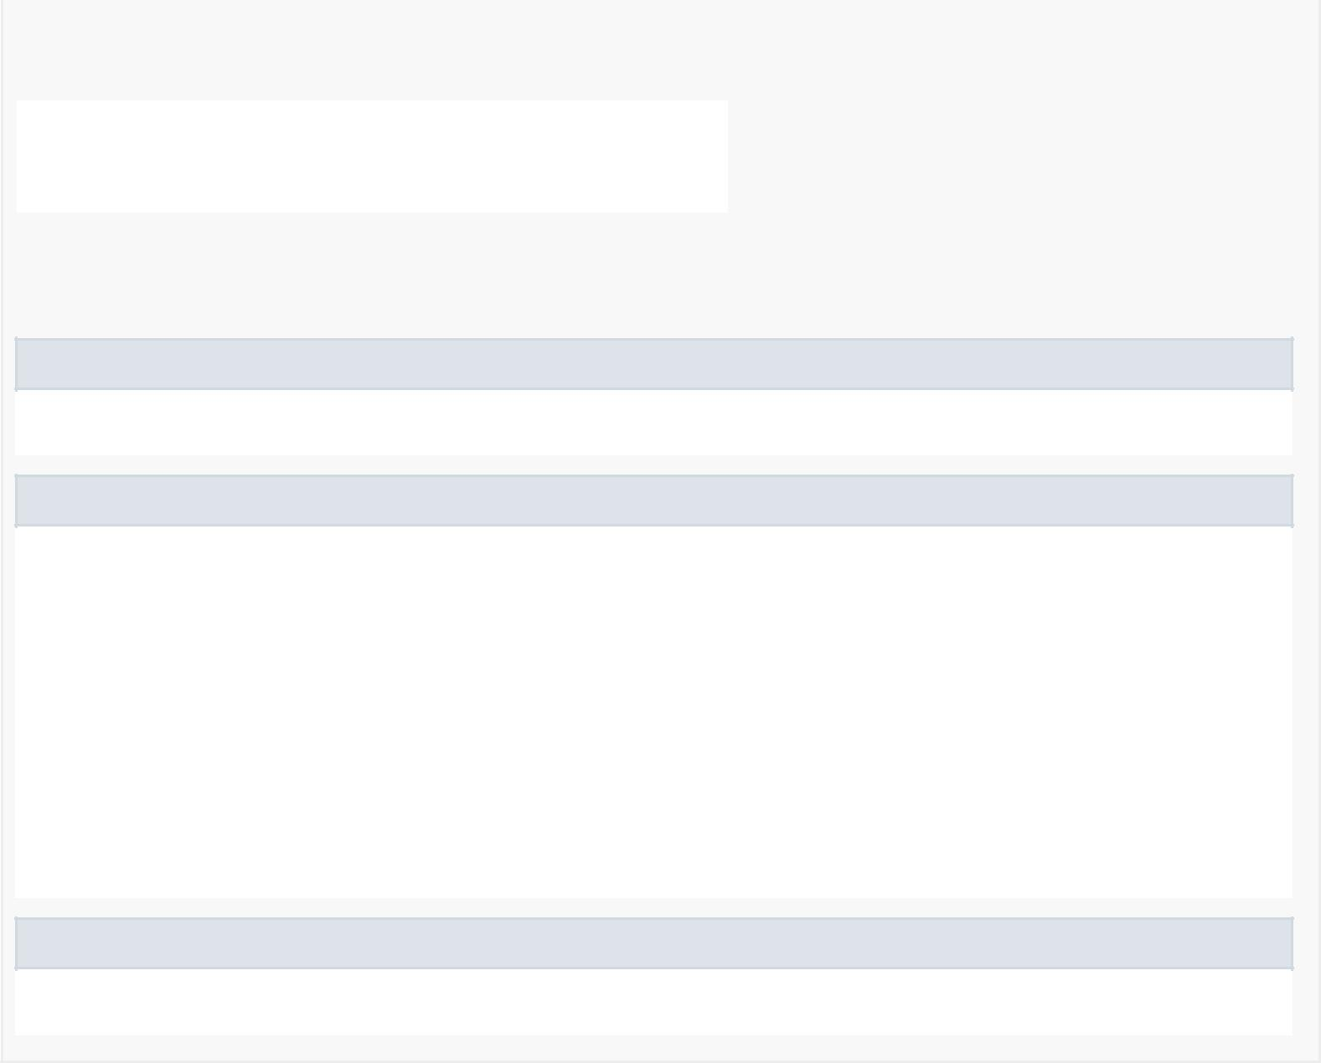

|  |  |
| --- | --- |
| private android.widget.EditText | mPasswordView |
|  | Contains a EditText of |
|  | the password of the |
|  | account that is logging in |
| private android.app.ProgressDialog | progressDialog |
|  | Contains a |
|  | ProgressDialog of the |
|  | account that is logging in |
|  |  |
| private static int | REQUEST_READ_CONTACTS |
|  | Id to identity |
|  | READ_CONTACTS |
|  | permission request. |
|  |  |

Fields inherited from class android.app.Activity

DEFAULT_KEYS_DIALER, DEFAULT_KEYS_DISABLE, DEFAULT_KEYS_SEARCH_GLOBAL, DEFAULT_KEYS_SEARCH_LOCAL, DEFAULT_KEYS_SHORTCUT,

FOCUSED_STATE_SET, RESULT_CANCELED, RESULT_FIRST_USER, RESULT_OK

Fields inherited from class android.content.Context

ACCESSIBILITY_SERVICE, ACCOUNT_SERVICE, ACTIVITY_SERVICE, ALARM_SERVICE, APP_OPS_SERVICE, APPWIDGET_SERVICE,

AUDIO_SERVICE, BATTERY_SERVICE, BIND_ABOVE_CLIENT, BIND_ADJUST_WITH_ACTIVITY, BIND_ALLOW_OOM_MANAGEMENT, BIND_AUTO_CREATE,

BIND_DEBUG_UNBIND, BIND_EXTERNAL_SERVICE, BIND_IMPORTANT, BIND_NOT_FOREGROUND, BIND_WAIVE_PRIORITY, BLUETOOTH_SERVICE,

CAMERA_SERVICE, CAPTIONING_SERVICE, CARRIER_CONFIG_SERVICE, CLIPBOARD_SERVICE, CONNECTIVITY_SERVICE, CONSUMER_IR_SERVICE,

CONTEXT_IGNORE_SECURITY, CONTEXT_INCLUDE_CODE, CONTEXT_RESTRICTED, DEVICE_POLICY_SERVICE, DISPLAY_SERVICE,

DOWNLOAD_SERVICE, DROPBOX_SERVICE, FINGERPRINT_SERVICE, HARDWARE_PROPERTIES_SERVICE, INPUT_METHOD_SERVICE, INPUT_SERVICE,

JOB_SCHEDULER_SERVICE, KEYGUARD_SERVICE, LAUNCHER_APPS_SERVICE, LAYOUT_INFLATER_SERVICE, LOCATION_SERVICE,

MEDIA_PROJECTION_SERVICE, MEDIA_ROUTER_SERVICE, MEDIA_SESSION_SERVICE, MIDI_SERVICE, MODE_APPEND,

MODE_ENABLE_WRITE_AHEAD_LOGGING, MODE_MULTI_PROCESS, MODE_NO_LOCALIZED_COLLATORS, MODE_PRIVATE, MODE_WORLD_READABLE,

MODE_WORLD_WRITEABLE, NETWORK_STATS_SERVICE, NFC_SERVICE, NOTIFICATION_SERVICE, NSD_SERVICE, POWER_SERVICE, PRINT_SERVICE,

RESTRICTIONS_SERVICE, SEARCH_SERVICE, SENSOR_SERVICE, SHORTCUT_SERVICE, STORAGE_SERVICE, SYSTEM_HEALTH_SERVICE,

TELECOM_SERVICE, TELEPHONY_SERVICE, TELEPHONY_SUBSCRIPTION_SERVICE, TEXT_SERVICES_MANAGER_SERVICE, TV_INPUT_SERVICE,

UI_MODE_SERVICE, USAGE_STATS_SERVICE, USB_SERVICE, USER_SERVICE, VIBRATOR_SERVICE, WALLPAPER_SERVICE, WIFI_P2P_SERVICE,

WIFI_SERVICE, WINDOW_SERVICE

Fields inherited from interface android.content.ComponentCallbacks2

TRIM_MEMORY_BACKGROUND, TRIM_MEMORY_COMPLETE, TRIM_MEMORY_MODERATE, TRIM_MEMORY_RUNNING_CRITICAL, TRIM_MEMORY_RUNNING_LOW,

TRIM_MEMORY_RUNNING_MODERATE, TRIM_MEMORY_UI_HIDDEN

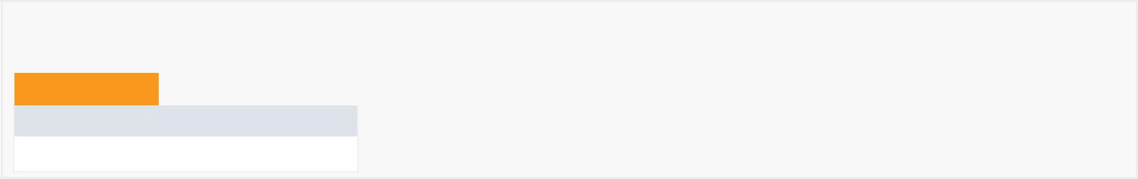

*Constructor Summary*

Constructors

Constructor and Description

LoginActivity()

|  |  |  |  |  |  |  |
| --- | --- | --- | --- | --- | --- | --- |
| *Method Summary* | | | |  |  |  |
|  |  |  |  |  |  |  |
|  | All Methods |  | [Instance Methods](javascript:show(2);) | [Concrete Methods](javascript:show(8);) |  |  |
|  | Modifier and Type | |  | Method and Description | |  |
|  | private void | |  | addEmailsToAutoComplete(java.util.List<java.lang.String> emailAddressCollection) | |  |
|  |  |  |  | Creates adapter to tell the AutoCompleteTextView what to show in its dropdown list. | |  |
|  | private void | |  | attemptLogin() | |  |
|  |  |  |  | Attempts to sign in or register the account specified by the login form. | |  |
|  | private boolean | |  | isEmailValid(java.lang.String email) | |  |
|  |  |  |  | Checks if the email is valid. | |  |
|  | private boolean | |  | isPasswordValid(java.lang.String password) | |  |
|  |  |  |  | Checks if the password is valid. | |  |
|  | private boolean | |  | mayRequestContacts() | |  |
|  |  |  |  | Requests the user's permission to access the contacts. | |  |
|  | void | |  | onBackPressed() | |  |



|  |  |
| --- | --- |
|  | Prevents the user from using the back button |
| protected void | onCreate(android.os.Bundle savedInstanceState) |
|  | Creates and inflates the layout of the activity. |
|  |  |
| android.content.Loader<android.database.Cursor> | onCreateLoader(int i, android.os.Bundle bundle) |
|  | Creates and inflates the layout of the loader. |
| void | onLoaderReset(android.content.Loader<android.database.Cursor> cursorLoader) |
|  | Handles if the loader is reset. |
|  |  |
| void | onLoadFinished(android.content.Loader<android.database.Cursor> cursorLoader, |
|  | android.database.Cursor cursor) |
|  | Handles if the loader is finished. |
| void | onRequestPermissionsResult(int requestCode, java.lang.String[] permissions, |
|  | int[] grantResults) |
|  | Callback received when a permissions request has been completed. |
|  |  |
| private void | populateAutoComplete() |
|  | Fills in the blanks if the permission for the contacts is not granted. |
| void | startRegisterActivityView(android.view.View view) |
|  | Starts the RegisterActivity |
|  |  |
| private void | userLogin(java.lang.String email, java.lang.String password) |
|  | Logs the user in |
|  |  |

Methods inherited from class android.support.v7.app.AppCompatActivity

addContentView, dispatchKeyEvent, findViewById, getDelegate, getDrawerToggleDelegate, getMenuInflater, getResources, getSupportActionBar, getSupportParentActivityIntent, invalidateOptionsMenu, onConfigurationChanged, onContentChanged, onCreateSupportNavigateUpTaskStack, onDestroy, onMenuItemSelected, onMenuOpened, onPanelClosed, onPostCreate, onPostResume, onPrepareSupportNavigateUpTaskStack, onSaveInstanceState, onStart, onStop, onSupportActionModeFinished, onSupportActionModeStarted, onSupportContentChanged, onSupportNavigateUp, onTitleChanged, onWindowStartingSupportActionMode, setContentView, setContentView, setContentView, setSupportActionBar, setSupportProgress, setSupportProgressBarIndeterminate, setSupportProgressBarIndeterminateVisibility, setSupportProgressBarVisibility, setTheme, startSupportActionMode, supportInvalidateOptionsMenu, supportNavigateUpTo, supportRequestWindowFeature, supportShouldUpRecreateTask

Methods inherited from class android.support.v4.app.FragmentActivity

dump, getLastCustomNonConfigurationInstance, getSupportFragmentManager, getSupportLoaderManager, getSupportMediaController, onActivityResult, onAttachFragment, onCreatePanelMenu, onLowMemory, onMultiWindowModeChanged, onNewIntent, onPause, onPictureInPictureModeChanged, onPrepareOptionsPanel, onPreparePanel, onResume, onResumeFragments, onRetainCustomNonConfigurationInstance, onRetainNonConfigurationInstance, onStateNotSaved, setEnterSharedElementCallback, setExitSharedElementCallback, setSupportMediaController, startActivityForResult, startActivityFromFragment, startActivityFromFragment, startIntentSenderFromFragment, supportFinishAfterTransition, supportPostponeEnterTransition, supportStartPostponedEnterTransition, validateRequestPermissionsRequestCode

Methods inherited from class android.support.v4.app.SupportActivity

getExtraData, putExtraData

Methods inherited from class android.app.Activity

closeContextMenu, closeOptionsMenu, createPendingResult, dismissDialog, dismissKeyboardShortcutsHelper, dispatchGenericMotionEvent, dispatchKeyShortcutEvent, dispatchPopulateAccessibilityEvent, dispatchTouchEvent, dispatchTrackballEvent, enterPictureInPictureMode, finish, finishActivity, finishActivityFromChild, finishAffinity, finishAfterTransition, finishAndRemoveTask, finishFromChild, getActionBar, getApplication, getCallingActivity, getCallingPackage, getChangingConfigurations, getComponentName, getContentScene, getContentTransitionManager, getCurrentFocus, getFragmentManager, getIntent, getLastNonConfigurationInstance, getLayoutInflater, getLoaderManager, getLocalClassName, getMediaController, getParent, getParentActivityIntent, getPreferences, getReferrer, getRequestedOrientation, getSearchEvent, getSystemService, getTaskId, getTitle, getTitleColor, getVoiceInteractor, getVolumeControlStream, getWindow, getWindowManager, hasWindowFocus, isChangingConfigurations, isChild, isDestroyed, isFinishing, isImmersive, isInMultiWindowMode, isInPictureInPictureMode, isLocalVoiceInteractionSupported, isTaskRoot, isVoiceInteraction, isVoiceInteractionRoot, managedQuery, moveTaskToBack, navigateUpTo, navigateUpToFromChild, onActionModeFinished, onActionModeStarted, onActivityReenter, onApplyThemeResource, onAttachedToWindow, onAttachFragment, onChildTitleChanged, onContextItemSelected, onContextMenuClosed, onCreate, onCreateContextMenu, onCreateDescription, onCreateDialog, onCreateDialog, onCreateNavigateUpTaskStack, onCreateOptionsMenu, onCreatePanelView, onCreateThumbnail, onDetachedFromWindow, onEnterAnimationComplete, onGenericMotionEvent, onKeyDown, onKeyLongPress, onKeyMultiple, onKeyShortcut, onKeyUp, onLocalVoiceInteractionStarted, onLocalVoiceInteractionStopped, onNavigateUp, onNavigateUpFromChild, onOptionsItemSelected, onOptionsMenuClosed, onPostCreate, onPrepareDialog, onPrepareDialog,

onPrepareNavigateUpTaskStack, onPrepareOptionsMenu, onProvideAssistContent, onProvideAssistData, onProvideKeyboardShortcuts, onProvideReferrer, onRestart, onRestoreInstanceState, onRestoreInstanceState, onSaveInstanceState, onSearchRequested, onSearchRequested, onTouchEvent, onTrackballEvent, onTrimMemory, onUserInteraction, onUserLeaveHint, onVisibleBehindCanceled, onWindowAttributesChanged, onWindowFocusChanged, onWindowStartingActionMode, onWindowStartingActionMode, openContextMenu, openOptionsMenu, overridePendingTransition, postponeEnterTransition, recreate, registerForContextMenu, releaseInstance, removeDialog, reportFullyDrawn, requestDragAndDropPermissions, requestPermissions, requestShowKeyboardShortcuts, requestVisibleBehind, requestWindowFeature, runOnUiThread, setActionBar, setContentTransitionManager, setDefaultKeyMode, setEnterSharedElementCallback, setExitSharedElementCallback, setFeatureDrawable, setFeatureDrawableAlpha, setFeatureDrawableResource, setFeatureDrawableUri, setFinishOnTouchOutside, setImmersive, setIntent, setMediaController, setProgress, setProgressBarIndeterminate, setProgressBarIndeterminateVisibility, setProgressBarVisibility, setRequestedOrientation, setResult, setResult, setSecondaryProgress, setTaskDescription, setTitle, setTitle, setTitleColor, setVisible, setVolumeControlStream, setVrModeEnabled, shouldShowRequestPermissionRationale, shouldUpRecreateTask, showAssist, showDialog, showDialog, showLockTaskEscapeMessage, startActionMode, startActionMode, startActivities, startActivities, startActivity, startActivity, startActivityFromChild, startActivityFromChild, startActivityFromFragment, startActivityFromFragment, startActivityIfNeeded, startActivityIfNeeded, startIntentSender, startIntentSender, startIntentSenderFromChild, startIntentSenderFromChild, startLocalVoiceInteraction, startLockTask, startManagingCursor, startNextMatchingActivity, startNextMatchingActivity, startPostponedEnterTransition, startSearch, stopLocalVoiceInteraction, stopLockTask, stopManagingCursor, takeKeyEvents, triggerSearch, unregisterForContextMenu



Methods inherited from class android.view.ContextThemeWrapper

applyOverrideConfiguration, attachBaseContext, getAssets, getTheme

Methods inherited from class android.content.ContextWrapper

bindService, checkCallingOrSelfPermission, checkCallingOrSelfUriPermission, checkCallingPermission, checkCallingUriPermission, checkPermission, checkSelfPermission, checkUriPermission, checkUriPermission, clearWallpaper, createConfigurationContext, createDeviceProtectedStorageContext, createDisplayContext, createPackageContext, databaseList, deleteDatabase, deleteFile, deleteSharedPreferences, enforceCallingOrSelfPermission, enforceCallingOrSelfUriPermission, enforceCallingPermission, enforceCallingUriPermission, enforcePermission, enforceUriPermission, enforceUriPermission, fileList, getApplicationContext, getApplicationInfo, getBaseContext, getCacheDir, getClassLoader, getCodeCacheDir, getContentResolver, getDatabasePath, getDataDir, getDir, getExternalCacheDir, getExternalCacheDirs, getExternalFilesDir, getExternalFilesDirs, getExternalMediaDirs, getFilesDir, getFileStreamPath, getMainLooper, getNoBackupFilesDir, getObbDir, getObbDirs, getPackageCodePath, getPackageManager, getPackageName, getPackageResourcePath, getSharedPreferences, getSystemServiceName, getWallpaper, getWallpaperDesiredMinimumHeight, getWallpaperDesiredMinimumWidth, grantUriPermission, isDeviceProtectedStorage, isRestricted, moveDatabaseFrom, moveSharedPreferencesFrom, openFileInput, openFileOutput, openOrCreateDatabase, openOrCreateDatabase, peekWallpaper, registerReceiver, registerReceiver, removeStickyBroadcast, removeStickyBroadcastAsUser, revokeUriPermission, sendBroadcast, sendBroadcast, sendBroadcastAsUser, sendBroadcastAsUser, sendOrderedBroadcast, sendOrderedBroadcast, sendOrderedBroadcastAsUser, sendStickyBroadcast, sendStickyBroadcastAsUser, sendStickyOrderedBroadcast, sendStickyOrderedBroadcastAsUser, setWallpaper, setWallpaper, startInstrumentation, startService, stopService, unbindService, unregisterReceiver

Methods inherited from class android.content.Context

getColor, getColorStateList, getDrawable, getString, getString, getSystemService, getText, obtainStyledAttributes, obtainStyledAttributes, obtainStyledAttributes, obtainStyledAttributes, registerComponentCallbacks, unregisterComponentCallbacks

Methods inherited from class java.lang.Object

clone, equals, finalize, getClass, hashCode, notify, notifyAll, toString, wait, wait, wait

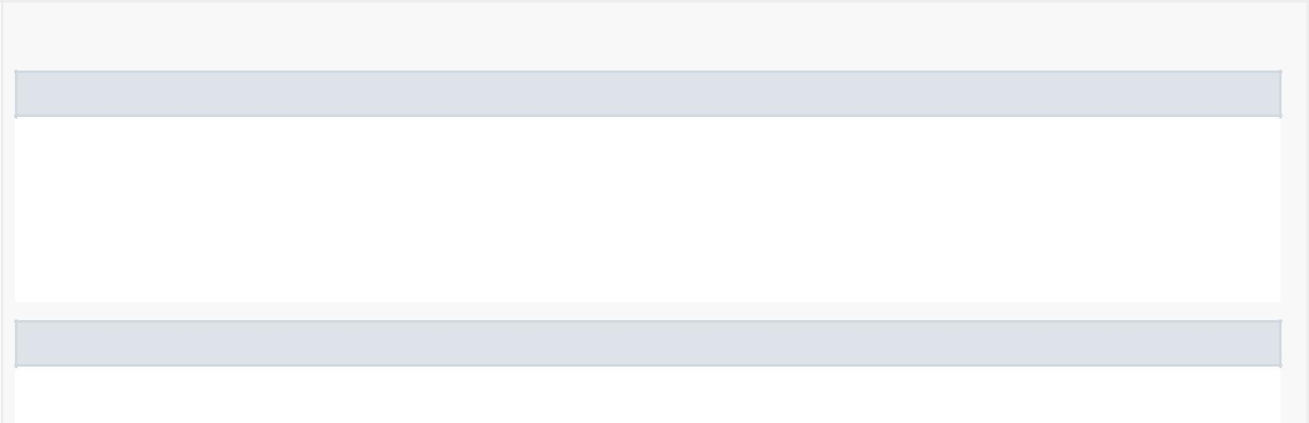

*Field Detail*

REQUEST_READ_CONTACTS

private static final int REQUEST_READ_CONTACTS

Id to identity READ_CONTACTS permission request.

See Also:

Constant Field Values

firebaseAuth

private com.google.firebase.auth.FirebaseAuth firebaseAuth

Defining Firebase auth object

progressDialog

private android.app.ProgressDialog progressDialog

Contains a ProgressDialog of the account that is logging in

mEmailView

private android.widget.AutoCompleteTextView mEmailView

Contains a AutoCompleteTextView of the email of the account that is logging in

mPasswordView

private android.widget.EditText mPasswordView

Contains a EditText of the password of the account that is logging in

cancel

private boolean cancel

Contains a boolean value of cancellation for the account that is logging in

focusView

private android.view.View focusView

Contains a View of the focus of the account that is logging in

mLoginFormView

private android.view.View mLoginFormView

Contains a View of the login form of the account that is logging in

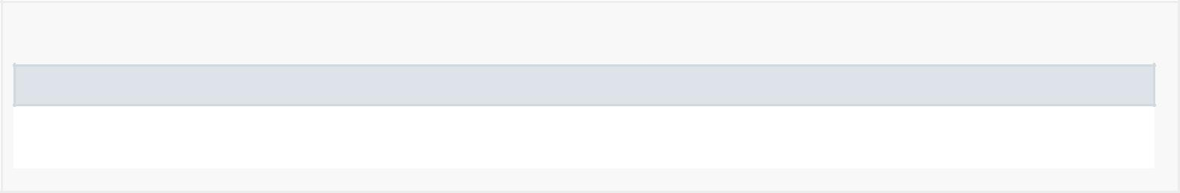

*Constructor Detail*

LoginActivity

public LoginActivity()

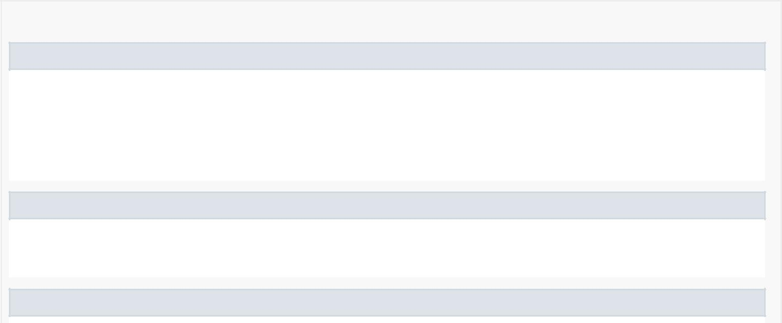

*Method Detail*

onCreate

protected void onCreate(android.os.Bundle savedInstanceState)

Creates and inflates the layout of the activity.

Overrides:

onCreate in class android.support.v7.app.AppCompatActivity

populateAutoComplete

private void populateAutoComplete()

Fills in the blanks if the permission for the contacts is not granted.

mayRequestContacts

private boolean mayRequestContacts()



Requests the user's permission to access the contacts.

onRequestPermissionsResult

public void onRequestPermissionsResult(int requestCode, @NonNull

java.lang.String[] permissions, @NonNull

int[] grantResults)

Callback received when a permissions request has been completed.

Specified by:

onRequestPermissionsResult in interface android.support.v4.app.ActivityCompat.OnRequestPermissionsResultCallback

Overrides:

onRequestPermissionsResult in class android.support.v4.app.FragmentActivity

attemptLogin

private void attemptLogin()

Attempts to sign in or register the account specified by the login form. If there are form errors (invalid email, missing fields, etc.), the errors are presented and no actual login attempt is made.

isEmailValid

private boolean isEmailValid(java.lang.String email)

Checks if the email is valid.

isPasswordValid

private boolean isPasswordValid(java.lang.String password)

Checks if the password is valid.

onCreateLoader

public android.content.Loader<android.database.Cursor> onCreateLoader(int i,

android.os.Bundle bundle)

Creates and inflates the layout of the loader.

Specified by:

onCreateLoader in interface android.app.LoaderManager.LoaderCallbacks<android.database.Cursor>

onLoadFinished

public void onLoadFinished(android.content.Loader<android.database.Cursor> cursorLoader, android.database.Cursor cursor)

Handles if the loader is finished.

Specified by:

onLoadFinished in interface android.app.LoaderManager.LoaderCallbacks<android.database.Cursor>

onLoaderReset

public void onLoaderReset(android.content.Loader<android.database.Cursor> cursorLoader)

Handles if the loader is reset.

Specified by:

onLoaderReset in interface android.app.LoaderManager.LoaderCallbacks<android.database.Cursor>

addEmailsToAutoComplete

private void addEmailsToAutoComplete(java.util.List<java.lang.String> emailAddressCollection)

Creates adapter to tell the AutoCompleteTextView what to show in its dropdown list.

userLogin

private void userLogin(java.lang.String email, java.lang.String password)

Logs the user in

startRegisterActivityView

public void startRegisterActivityView(android.view.View view)

Starts the RegisterActivity

onBackPressed

public void onBackPressed()

Prevents the user from using the back button

Overrides:

onBackPressed in class android.support.v4.app.FragmentActivity